I am going to begin with a problem that doesn’t occur, at least not in its full fledged form. This non-occurrence is a particularly interesting feature of this problem, as its existence is predicted by most theories. As is clear in the scientific method, a conflict between theory and data most likely results in a required theoretical revision. We will see that this is the case. The problem is called *conceptual misalignment* and it is when the concepts or meanings that one agent associated with a set of symbols is different from the concepts or meanings that another agent associates with those same signals. It becomes a problem only when these two agents attempt to communicate using these symbols.

When this attempt at communication occurs, it looks like this:

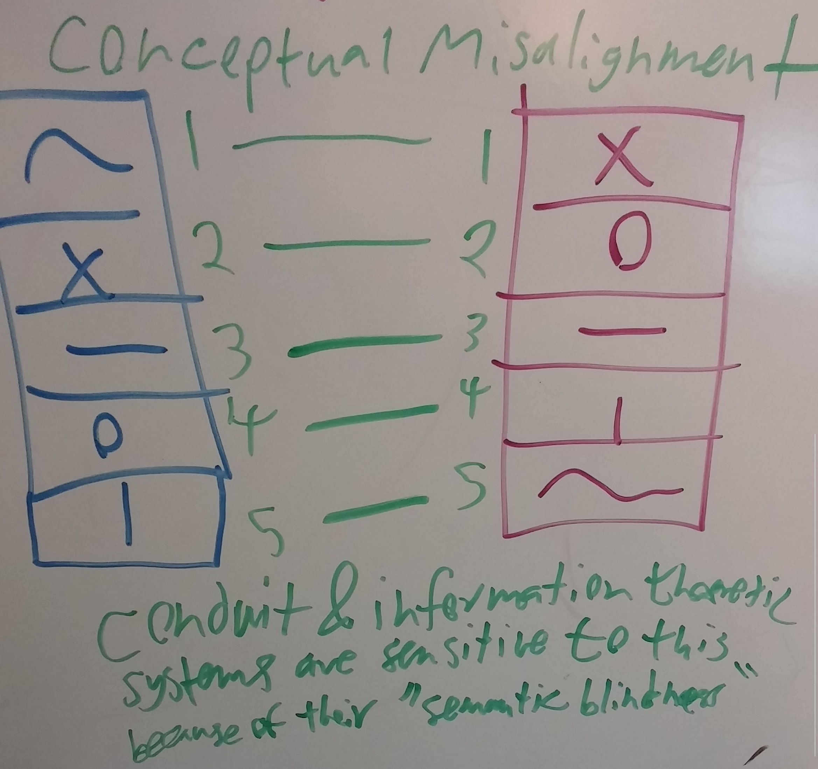

You might disagree and say that this does occur, or you might contest my glossing over exactly what concepts and meanings are. I will address these things in due time, as my argument truly—as you may have already discovered—hinges upon these points.

Instead of delving right into detail, let us first explore what would happen if this were to occur, especially in a system as illustrated. Such a system has a discrete and independent set of meanings, which is to say that none of the meanings necessarily have anything to do with each other and that there are no shades of meaning, only binary or propositional meanings or concepts which are either transmitted or not. This picture looks a bit like communication in a computer and so we will start there.

If this conceptual misalignment were to occur in such a communicative system, the wrong meanings would simply be transmitted and the receiving system would probably throw some sort of fit or error or fail at whatever it was trying to do with the veridical results of this communication. As stated, such a system could not correct, nor could it realize that there was anything wrong because such behaviors require an understanding of what a correct message should look like or a *meaning expectation*. Without such an expectation, the receiving agent simply receives and does whatever it would do with a correctly transmitted message. Here we define a correctly transmitted message or *perfect communication* to be when the meaning held by the transmitting agent is grasped by the receiving agent through a communicative process, which traditionally takes the form of a signal. Perfect communication always occurs in such a system when the communicating agents are in perfect *conceptual alignment*, which is the state that occurs when both agents have exactly the same sets of meanings mapped to the same sets of signals. Of course this perfection is under the assumption of noiseless transmission, which will hold throughout this paper. I claim and will later show experimental evidence to defend the fact that the only agents that are ever in perfect conceptual alignment are digital computers and programs and things that were explicitly designed such that a signal will always map from the input to the output.

Now, you might say, HEY, there are many processes where perfect communication occurs without conceptual alignment. This is true, so let us explore.

Actually I am pretty sure that conceptual alignment is not required as much as knowledge of what the signal is signaling. In many cases this knowledge is acquired easily by observing the contingencies between the signal and the world such that we know what in the world causes such a signal and therefore can later rely on the signal as a signal for the thing in the world. However, in many cases this is not possible, since there is no way to directly observe the thing that is being signaled. In this cases, knowledge of what is being signaled by the signal must be acquired in some other manner. This manner involves complex conditional and causal inference.

* talk about information theoretic models
* talk about prediction or schemas of meaning
* talk about meaning contingencies including the consistency of messages with respect to a set of hypotheses
* talk about interaction and causal inference
* ta